Contents

Abstract 3

Introduction 4

Related Work 4

Limitation of Work 4

Requirements 5

All Features 5

Completed Features 5

Description & Lacking 6

Sensor & Module 6

PIR Sensor 6

Flame sensor 7

Motor Driver 9

Servo motor 10

Water Pump 11

Speaker & LM386 Audio amplifier module 11

Relay 12

SD card module 12

Arduino UNO 14

Robot Body & Wheel 15

Activity diagram 16

Use-Case Diagram 17

Block Diagram 18

Circuit Diagram 19

Prototype 20

Features 21

Gantt chart 22

Programing Code 23

Arduino One 23

Arduino Two 24

FUTURE SCOPE 26

The Wide Application of IOT based fire fighter 26

ANALYSIS & BENEFITS 26

CONCLUSION 27

References 27

# Abstract

Now a day’s fire defending system in our country is becoming poor and poor. To overcome from this situation, we need to do something more special that’s why we proposed a hardware-based solution. It will work as fire fighter but using the technology of IOT. Early detection of the fire which produces a rapid action is essential in any firefighting system. A suggested smart system based on Internet of things is presented. Arduino Mega 2560 with the flame sensors is the core of the proposed system to detect the fire. The entire city is monitored remotely via the Internet by the smart center of firefighting, which is distributed in various locations. Device Bit and Blank platforms have been used for monitoring and sending notification immediately with the fire location to the smart center of firefighting. The proposed system is designed and implemented to be flexible, efficient with low cost to be practical and applicable

# Introduction

IOT based fire fighter is hardware-based project. In our country fire preventing system is need to be modern for reduce major damage. We are trying to make project that will act like a fire fighter and help to protect the public in the emergency situation.

Fire fighter IOT belongs to the application of IOT in firefighting industries. The three main characteristics of IOT are “fully perceivable, reliable transmission and information processing”, which precisely matches the “fire disaster surveillance, alarming and disposal” practiced in firefighting management, so IOT can be used to be built into a “firewall” of social security, propel the “four capacities” building of social entities in technology and assure the urban firefighting security and maintain social stability.

# Related Work

* **IOT Based Fire Department Alerting System**: IOT based automatic fire department alerting system that instantly and automatically alerts the fire department and informs about the situation so that immediate action can be taken. The system uses Fire sensor along with PIR sensor to efficiently detect fires and alert fire department over IOT.
* **Arduino Based Fire Fighting Robot**: Fire Fighting Robot using Arduino, which will automatically sense the fire and start the water pump. This is very simple robot that could move towards the fire and pump out water around it to put down the fire

# Limitation of Work

* IOT Based Fire Department Alerting System only works for fire detection
* They only flow the water
* There is no way to detect human in incident
* During incident there is no way to guide the victims.

# Requirements

1. Arduino
2. Temperature Sensor
3. PIR Sensor.
4. Relay
5. Speaker
6. Sd Card Module
7. Human detect IR Sensor.
8. Breadboard
9. Jumping Wire

# All Features

1. Can throw water in various direction.
2. Detect fire and inform authority over GSM.
3. Automatic off the power of that place.
4. Detect human existence during accident.
5. Give voice command so that public can take right decision during incident

# Completed Features

1. Can throw water in various direction.
2. Automatic off the power of that place.
3. Detect human existence during accident.
4. Give voice command so that public can take right decision during incident

# Description & Lacking

We try here to do some unique thing in IOT based fire fighter robot with focus for public help to save from fire, we try to do our best for this project but without Allah nobody is have full perfections and all of device and sensor have not efficacy of 100%. So, we have some lacking like as

1. Speaker voice is not normalized or clear sound because of Arduino output audio signal is not clear
2. Servo motor is working slow & sometime it shaking or vrbaite by it self
3. Motor driver run on 12v so the robot wheel performs very fast
4. Sometime PIR sensor detect motion without any human movement
5. Integrated voltage divider of Arduino getting very hot &
6. Sometime sensor is not working properly for loose connection

we intergraded here PIR sensor, Speaker & Relay for detect human motion, Voice command for people patience & power off this place in one Arduino module.

Another Arduino model we integrated their Motor driver, Fire detector (Flame sensor), Servo motor & water pump for robot wheel to run any ware, detect fire in 180-degree angle, water through position & water through

# Sensor & Module

## PIR Sensor

A passive infrared sensor (PIR sensor) is an electronic sensor that measures infrared (IR) light radiating from objects in its field of view. They are most often used in PIR-based motion detectors. PIR sensors are commonly used in security alarms and automatic lighting applications. PIR sensors detect general movement, but do not give information on who or what moved. For that purpose, an active IR sensor is required.

PIR sensors are commonly called simply "PIR", or sometimes "PID", for "passive infrared detector". The term passive refers to the fact that PIR devices do not radiate energy for detection purposes. They work entirely by detecting infrared radiation (radiant heat) emitted by or reflected from objects.

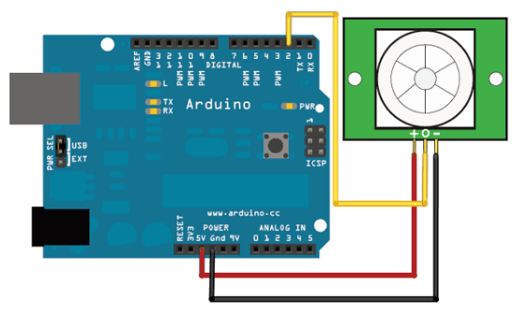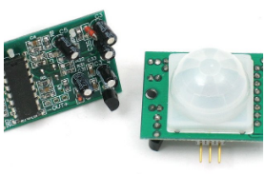

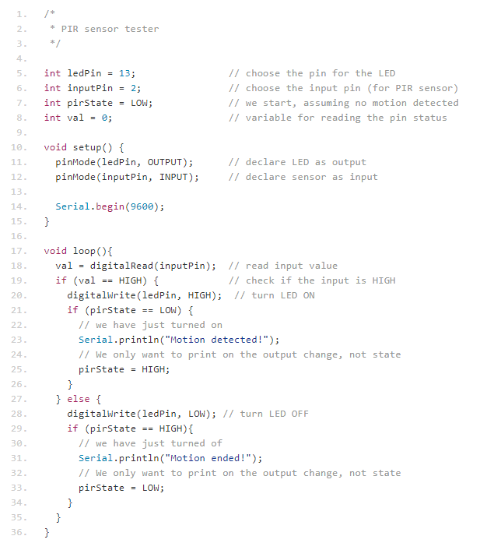

Fig – 1: PIR Sensor

## Flame sensor

A flame detector is a sensor designed to detect and respond to the presence of a flame or fire, allowing flame detection. Responses to a detected flame depend on the installation, but can include sounding an alarm, deactivating a fuel line (such as a propane or a natural gas line), and activating a fire suppression system. When used in applications such as industrial furnaces, their role is to provide confirmation that the furnace is working properly; in these cases, they take no direct action beyond notifying the operator or control system. A flame detector can often respond faster and more accurately than a smoke or heat detector due to the mechanisms it uses to detect the flame.

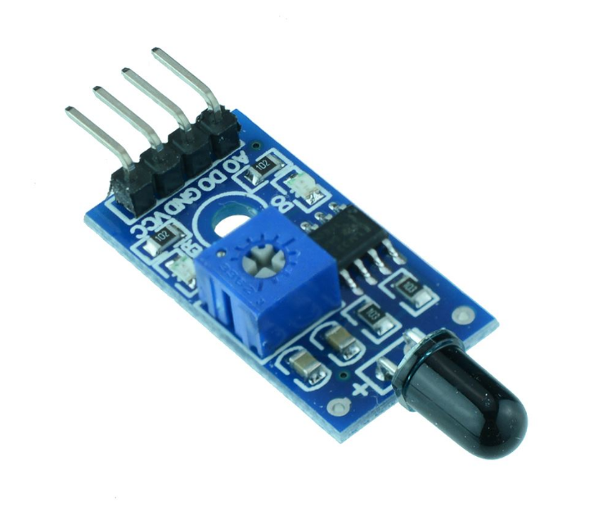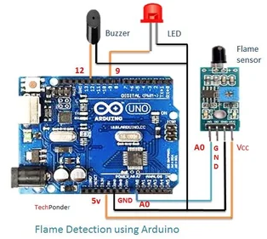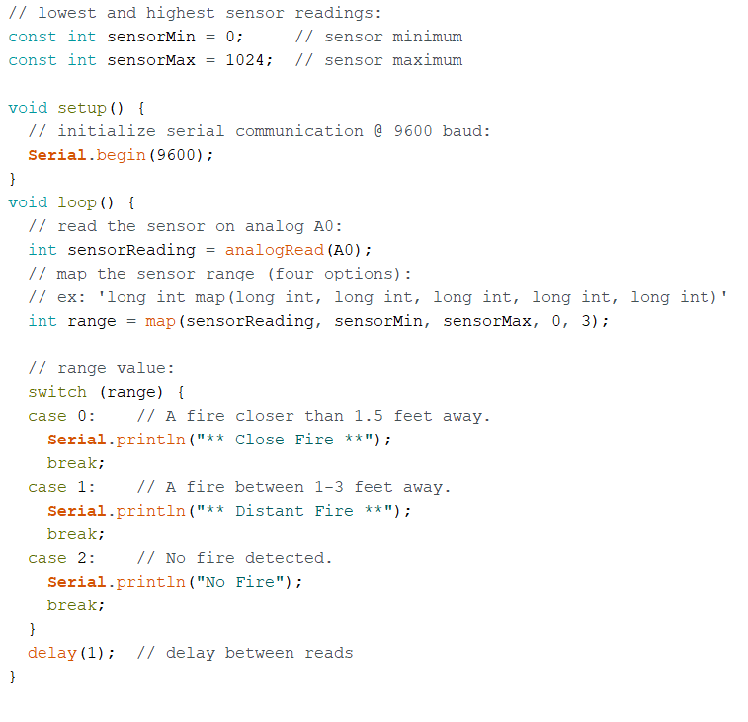

Fig – 2: Flame Sensor

## Motor Driver

The L298N is an integrated monolithic circuit in a 15- lead Milliwatt and PowerSO20 packages. It is a high voltage, high current dual full-bridge driver de-signed to accept standard TTL logic level sand drive inductive loads such as relays, solenoids, DC and stepping motors. Two enable inputs are provided to enable or disable the device independently of the in-put signals. The emitters of the lower transistors of each bridge are connected together rand the corresponding external terminal can be used for the connection of an external sensing resistor. An additional Supply input is provided so that the logic works at a lower voltage.

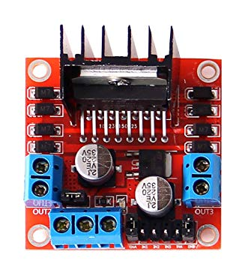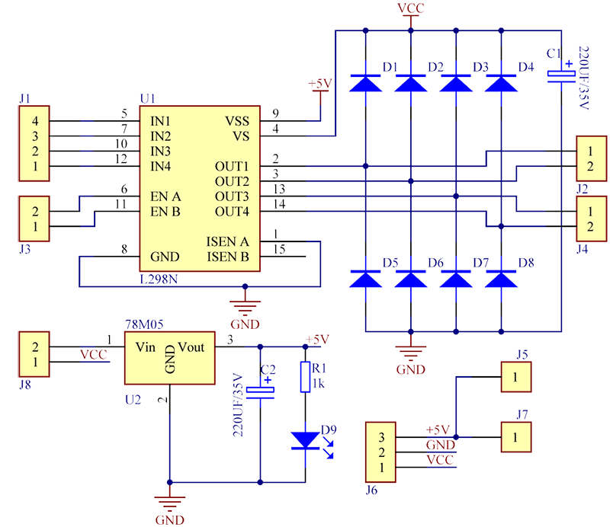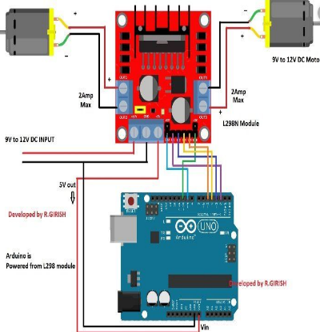

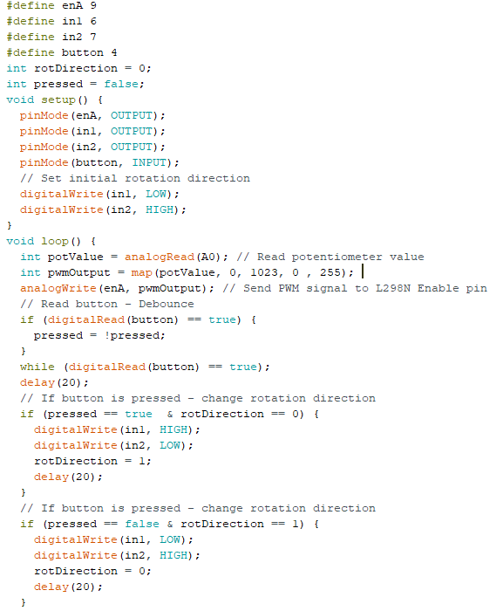

Fig – 3: Motor Driver

## Servo motor

A servomotor is a rotary actuator or linear actuator that allows for precise control of angular or linear position, velocity and acceleration. It consists of a suitable motor coupled to a sensor for position feedback. It also requires a relatively sophisticated controller, often a dedicated module designed specifically for use with servomotors. Servomotors are not a specific class of motor, although the term servomotor is often used to refer to a motor suitable for use in a closed-loop control system. Servomotors are used in applications such as robotics, CNC machinery or automated manufacturing.

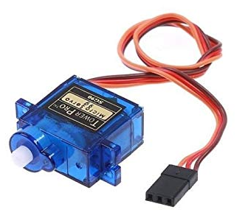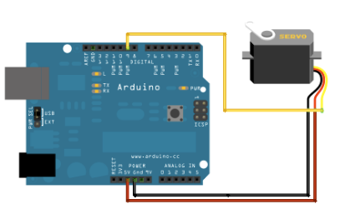

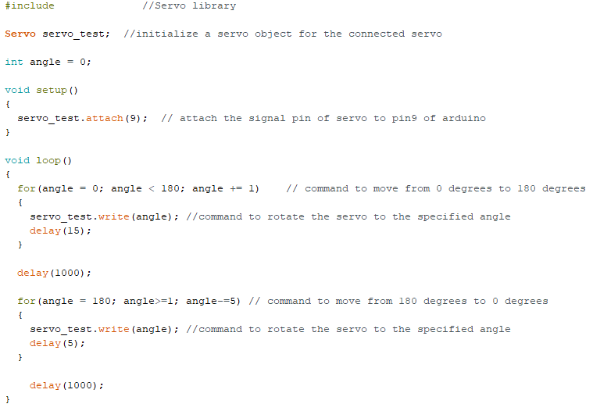

Fig – 4: Servo Motor

## Water Pump

A water pump is a mechanical device that is designed to circulate coolant through water-cooled engines. Although not all water-cooled engines use water pumps, these components are at the heart of nearly all modern water-cooling systems. Water pumps are typically driven via the rotation of the crankshaft, although that can be accomplished in a variety of different ways. There are also a number of different styles of pumps that are commonly used.

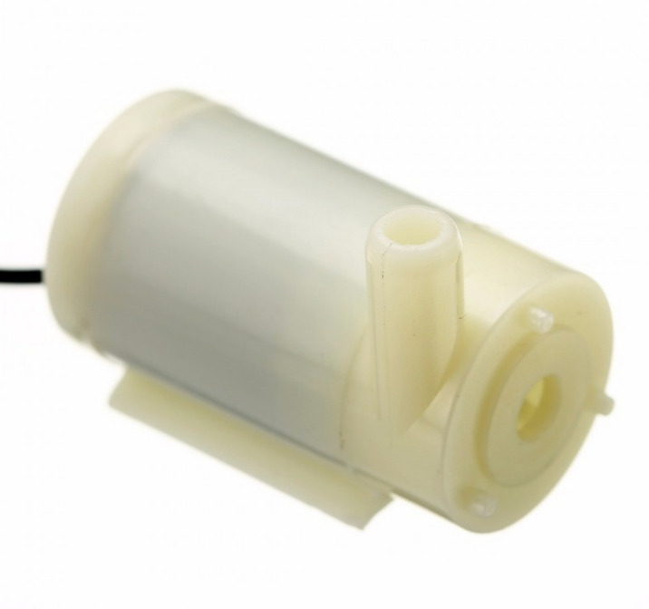

Fig – 5: Water Pump

## Speaker & LM386 Audio amplifier module

The LM386 Audio Amplifier Module is a mono audio amplifier based on the LM386 chip. It goes by various names and descriptions such as "LM386 Audio Amplifier Module 200 Times 5V-12V Input 10K Adjustable Resistance. LM386M chip is available in a SO package (M) manufactured by Texas Instruments, and operates on a voltage range between 4 V and 12 V. It has an absolute maximum rating of 15 V. Package (M) has a dissipation rating of 0.73 W. The LM386M version of the chip will provide a typical output of 325 mW, when the supply voltage is 6 V and the speaker load 8 Ω. A 9 V battery power supply will provide an output of around 500 mW. The size of the PCB is 41 mm × 13 mm, manufactured using SMD components, and arrives ready assembled. This will save the user much time and resources. As you can see, the PCB manufacturing is to a high-quality standard, and the one I received worked straight away without any problems.

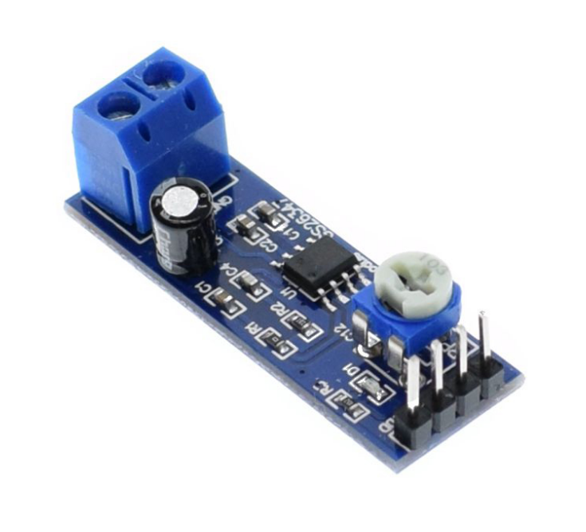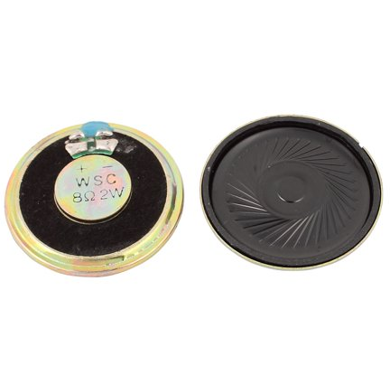

Fig – 6: Speaker & Audio Amplifier Module

## Relay

Relays are switching that open and close circuits electromechanically or electronically. Relays control one electrical circuit by opening and closing contacts in another circuit. As relay diagrams show, when a relay contact is normally open (NO), there is an open contact when the relay is not energized. When a relay contact is Normally Closed (NC), there is a closed contact when the relay is not energized. In either case, applying electrical current to the contacts will change their state.

Relays are generally used to switch smaller currents in a control circuit and do not usually control power consuming devices except for small motors and Solenoids that draw low amps. Nonetheless, relays can "control" larger voltages and amperes by having an amplifying effect because a small voltage applied to a relays coil can result in a large voltage being switched by the contacts.

Protective relays can prevent equipment damage by detecting electrical abnormalities, including overcurrent, undercurrent, overloads and reverse currents. In addition, relays are also widely used to switch starting coils, heating elements, pilot lights and audible alarms.

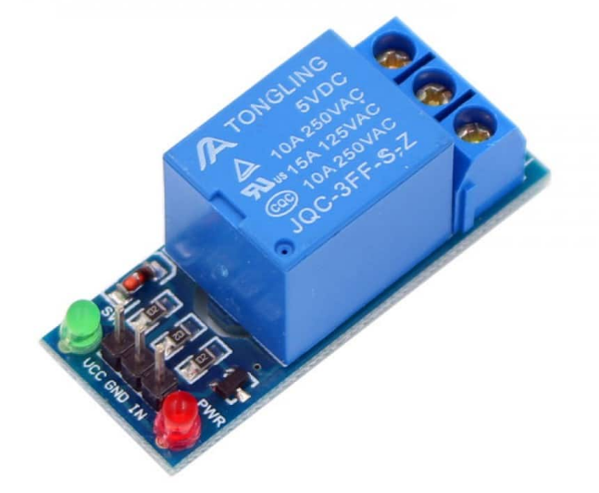

Fig – 7: Relay

## SD card module

The micro- SD Card Module is a simple solution for transferring data to and from a standard SD card. The pin out is directly compatible with Arduino, but can also be used with other microcontrollers. It allows you to add mass storage and data logging to your project. This module has SPI interface which is compatible with any SD card and it use 5V or 3.3V power supply which is compatible with Arduino UNO/Mega. SD module has various applications such as data logger, audio, video, graphics. This module will greatly expand the capability an Arduino can do with their poor limited memory.

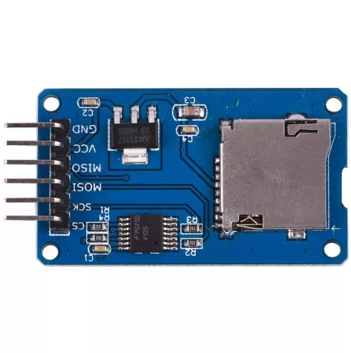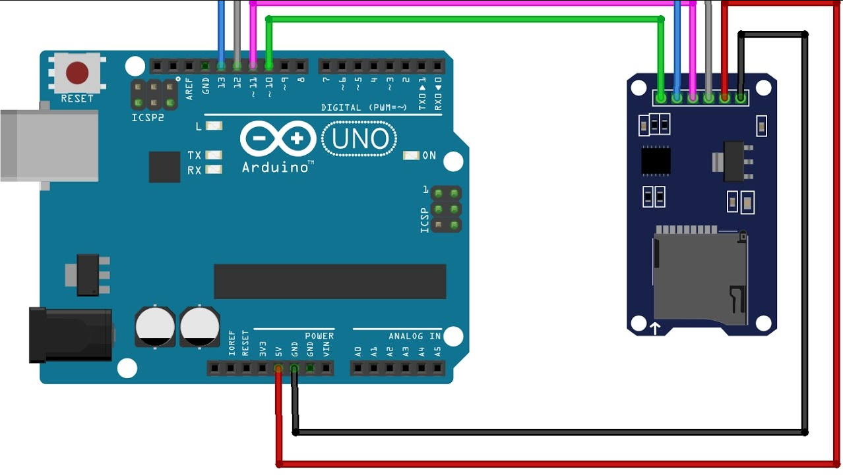

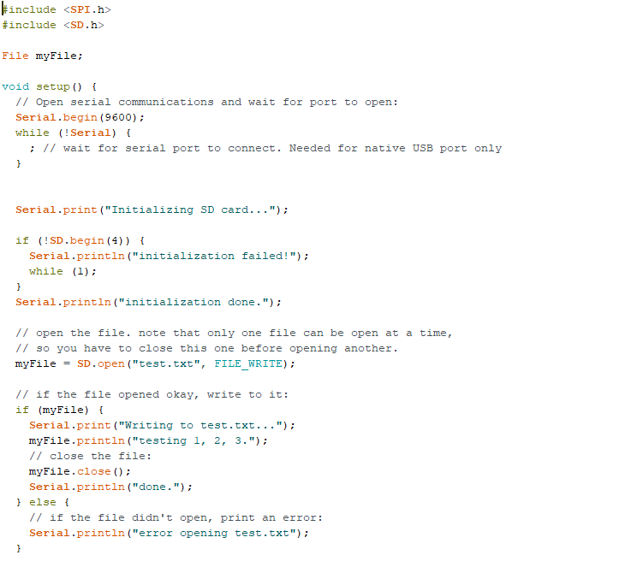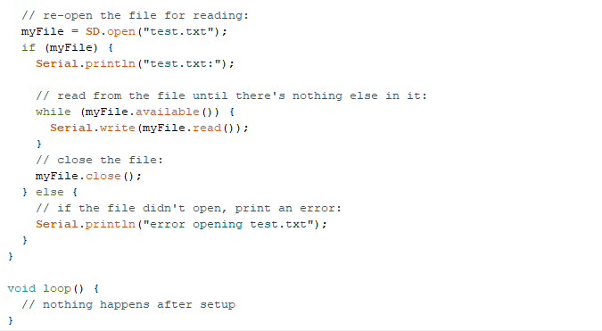

Fig – 8: SD Card Module

## Arduino UNO

Arduino Uno is a microcontroller board based on the ATmega328P (datasheet). It has 14 digital input/output pins (of which 6 can be used as PWM outputs), 6 analog inputs, a 16 MHz quartz crystal, a USB connection, a power jack, an ICSP header and a reset button. It contains everything needed to support the microcontroller; simply connect it to a computer with a USB cable or power it with a AC-to-DC adapter or battery to get started. You can tinker with your UNO without warring too much about doing something wrong, worst case scenario you can replace the chip for a few dollars and start over again. "Uno" means one in Italian and was chosen to mark the release of Arduino Software (IDE) 1.0. The Uno board and version 1.0 of Arduino Software (IDE) were the reference versions of Arduino, now evolved to newer releases. The Uno board is the first in a series of USB Arduino boards, and the reference model for the Arduino platform; for an extensive list of current, past or outdated boards see the Arduino index of boards.

|  |  |
| --- | --- |
| Microcontroller | [**ATmega328P**](http://ww1.microchip.com/downloads/en/DeviceDoc/ATmega48A-PA-88A-PA-168A-PA-328-P-DS-DS40002061A.pdf) |
| Operating Voltage | 5V |
| Input Voltage (recommended) | 7-12V |
| Input Voltage (limit) | 6-20V |
| Digital I/O Pins | 14 (of which 6 provide PWM output) |
| PWM Digital I/O Pins | 6 |
| Analog Input Pins | 6 |
| DC Current per I/O Pin | 20 mA |
| DC Current for 3.3V Pin | 50 mA |
| Flash Memory | 32 KB (ATmega328P) of which 0.5 KB used by bootloader |
| SRAM | 2 KB (ATmega328P) |
| EEPROM | 1 KB (ATmega328P) |
| Clock Speed | 16 MHz |
| LED_BUILTIN | 13 |
| Length | 68.6 mm |
| Width | 53.4 mm |
| Weight | 25 g |

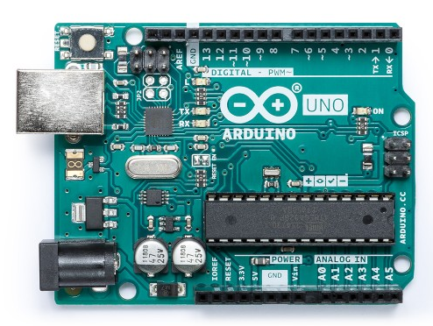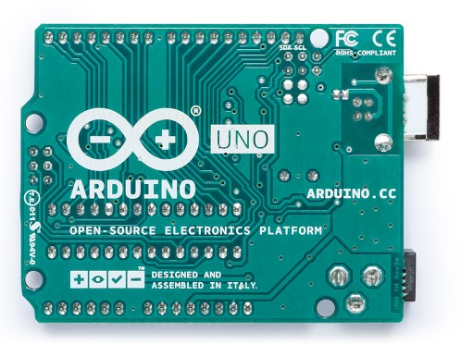

Fig – 9: Arduino UNO

## Robot Body & Wheel

DC 6V 2-wheel Robot Smart Car Chassis with Speed Encoder for Arduino. The mechanical structure is very simple and easy to install. An excellent platform for Line Following robots and Maze Solving Robots. The chassis has enough room for all the necessary electronics. This robot chassis together with Arduino UNO R3 makes an ideal DIY project Kit.

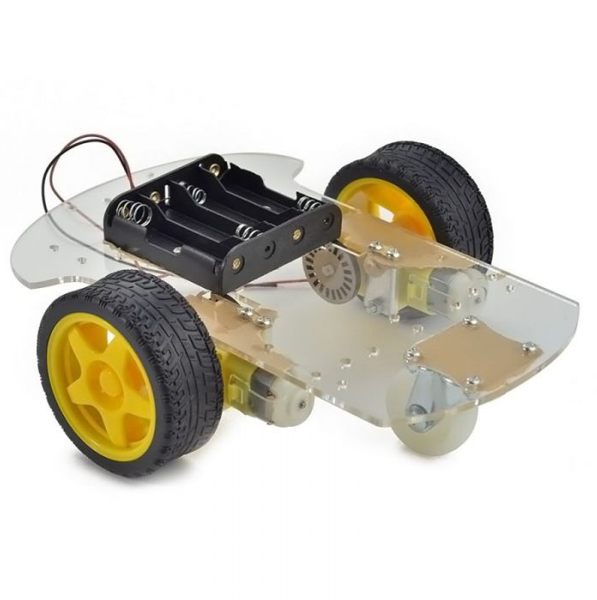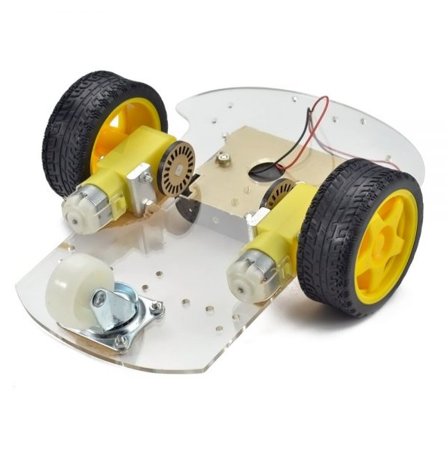

Fig – 10: Robot Body & Wheel

# Activity diagram

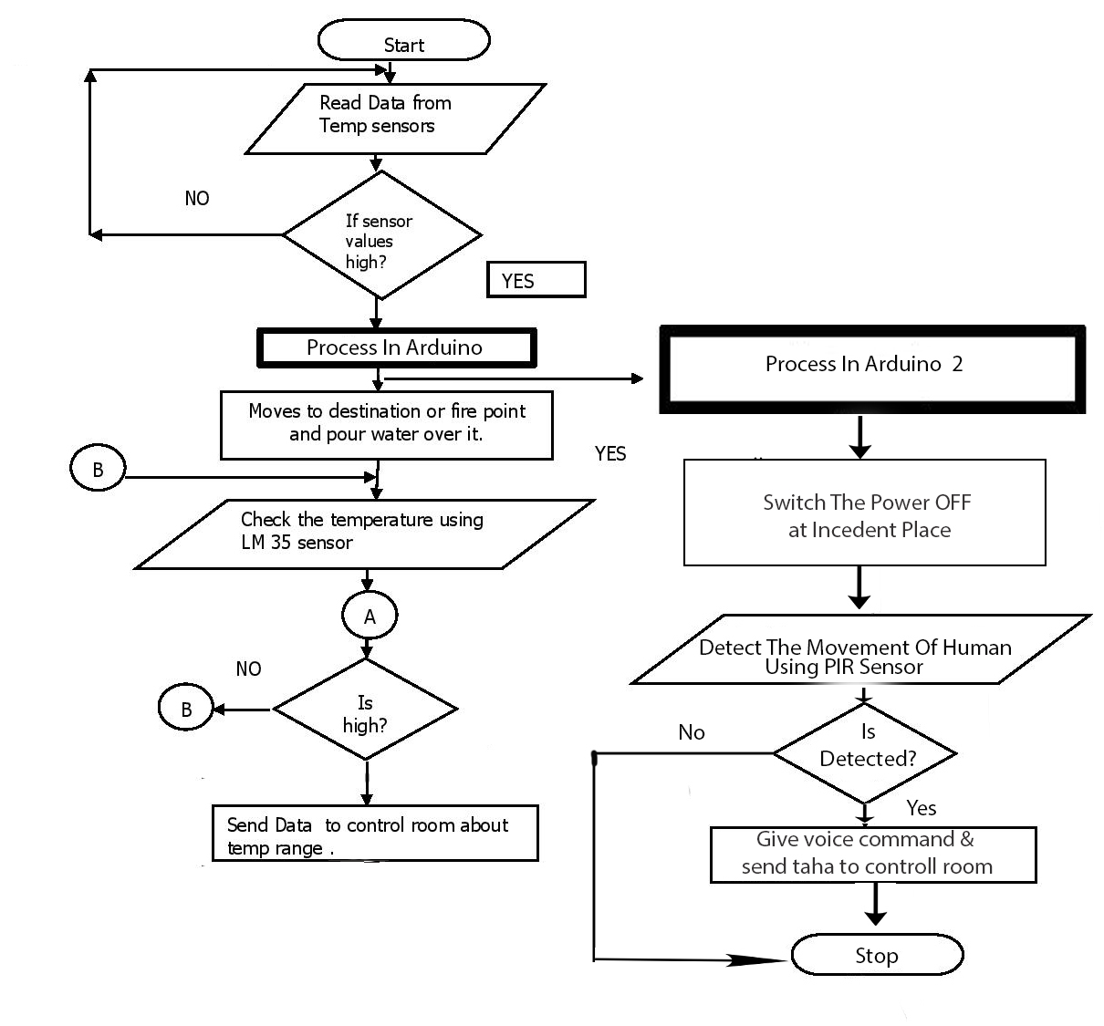

Fig – 11: Activity Diagram

# Use-Case Diagram

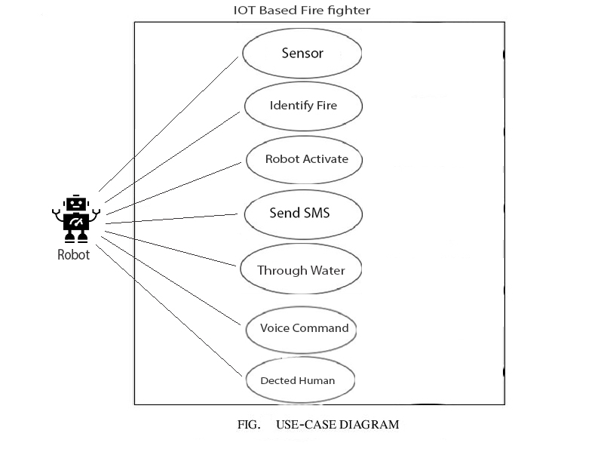

Fig – 12: USE-Case Diagram

# Block Diagram

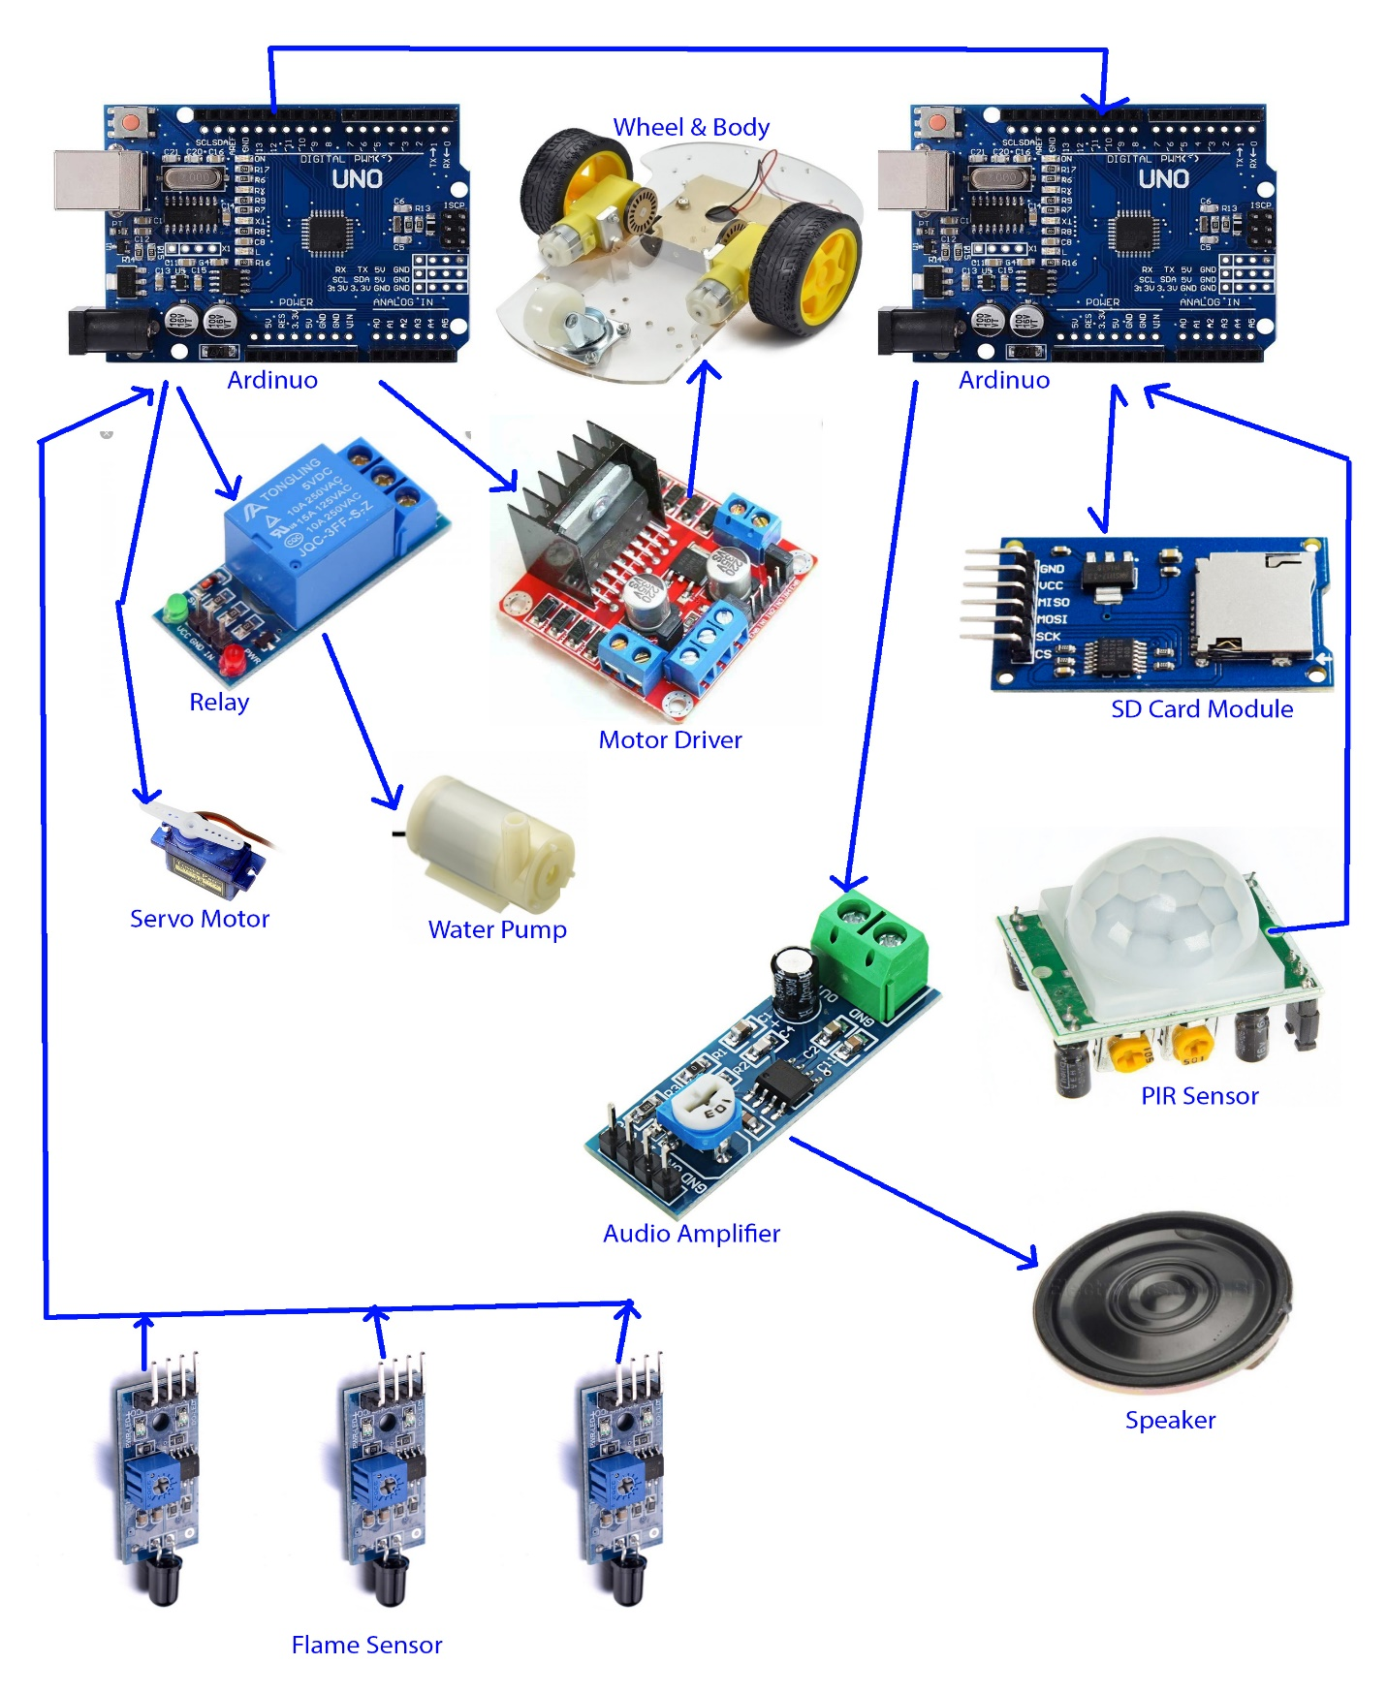

Fig – 13: Block Diagram

# Circuit Diagram

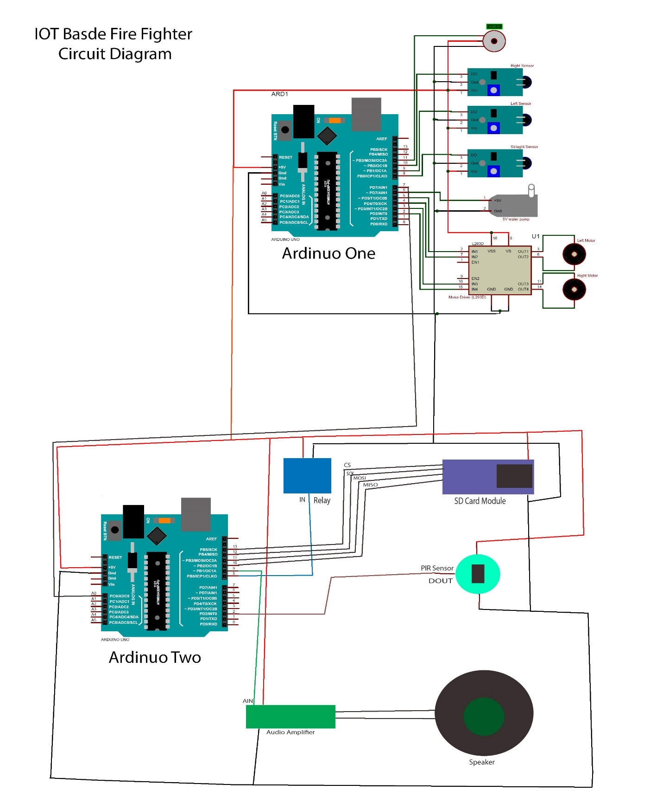

Fig – 14: Circuit Diagram

# Prototype

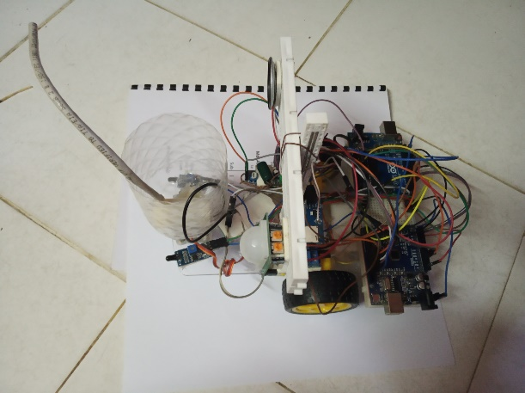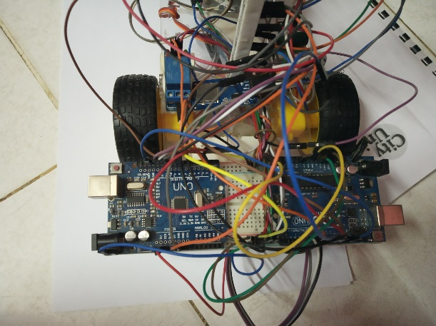

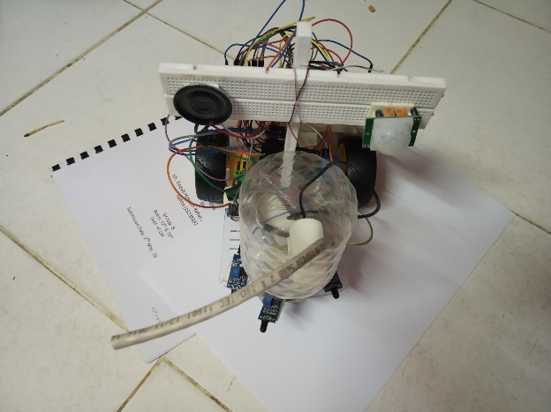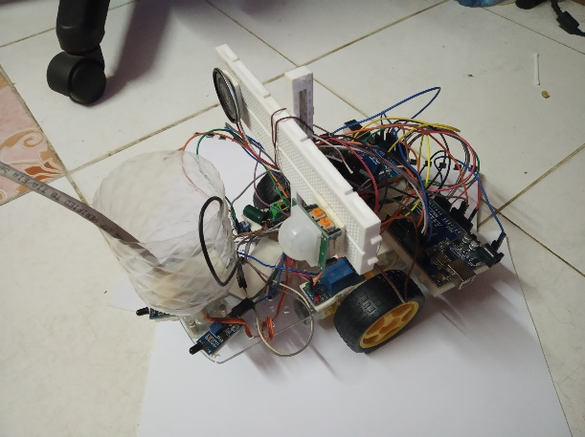

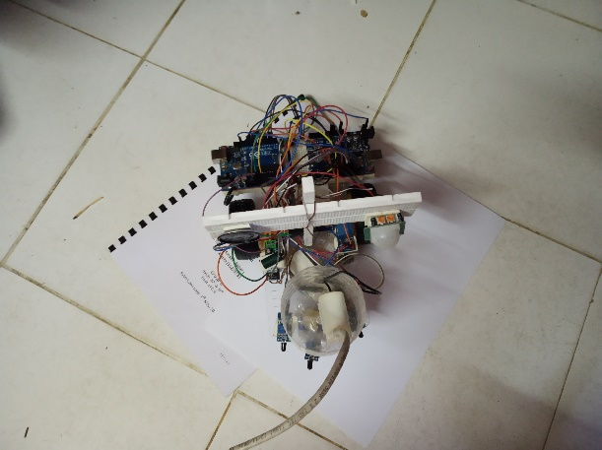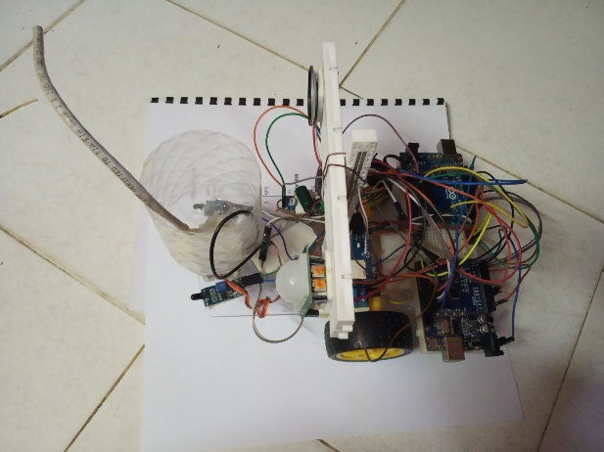

Fig – 15: Project ***Prototype***

# Features

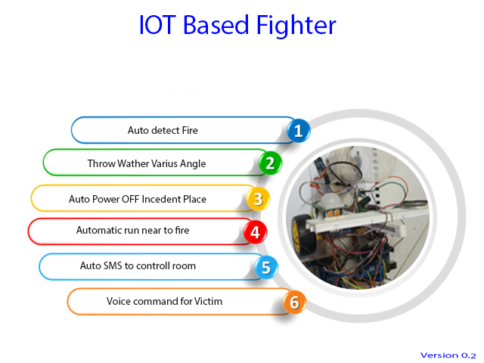

Fig – 16: Project ***Features***

# Gantt chart

|  |  |  |  |
| --- | --- | --- | --- |
| Task | Start Date | End Date | Duration |
| Gather Requirements | 7-Jul-19 | 11-Jul-19 | 4 |
| Buying Materials | 12-Jul-19 | 18-Jul-19 | 6 |
| Planning | 20-Jul-19 | 25-Jul-19 | 5 |
| Scheduling | 26-Jul-19 | 30-Jul-19 | 4 |
| Modeling | 1-Aug-19 | 3-Aug-19 | 2 |
| Implementation | 4-Aug-19 | 10-Sep-19 | 37 |
| Testing | 11-Sep-19 | 15-Sep-19 | 4 |
| Improvements | 18-Sep-19 | 26-Sep-19 | 8 |
| Final Testing | 26-Sep-19 | 27-Sep-19 | 1 |
| Release Version | 27-Sep-19 | 28-Sep-19 | 1 |

Fig – 17: ***Gantt chart***

# Programing Code

## Arduino One

#include <Servo.h>

Servo myservo;

int pos = 0;

boolean fire = false;

#define Left_S 9

#define Right_S 10

#define Forward_S 8

#define LM1 2

#define LM2 3

#define RM1 4

#define RM2 5

#define pump 6

void setup(){

pinMode(Left_S, INPUT);

pinMode(Right_S, INPUT);

pinMode(Forward_S, INPUT);

pinMode(LM1, OUTPUT);

pinMode(LM2, OUTPUT);

pinMode(RM1, OUTPUT);

pinMode(RM2, OUTPUT);

pinMode(pump, OUTPUT);

myservo.attach(11);

myservo.write(90);

}

void put_off_fire(){

delay (500);

digitalWrite(LM1, HIGH);

digitalWrite(LM2, HIGH);

digitalWrite(RM1, HIGH);

digitalWrite(RM2, HIGH);

digitalWrite(pump, HIGH); delay(500);

for (pos = 50; pos <= 130; pos += 1) {

myservo.write(pos);

delay(10);

}

for (pos = 130; pos >= 50; pos -= 1) {

myservo.write(pos);

delay(10);

}

digitalWrite(pump,LOW);

myservo.write(90);

fire=false;

}

void loop() {

myservo.write(90);

if (digitalRead(Left_S) ==1 && digitalRead(Right_S)==1 && digitalRead(Forward_S) ==1) {

digitalWrite(LM1, HIGH);

digitalWrite(LM2, HIGH);

digitalWrite(RM1, HIGH);

digitalWrite(RM2, HIGH);

}else if (digitalRead(Forward_S) ==0){

digitalWrite(LM1, HIGH);

digitalWrite(LM2, LOW);

digitalWrite(RM1, HIGH);

digitalWrite(RM2, LOW);

fire = true;

}else if (digitalRead(Left_S) ==0){

digitalWrite(LM1, HIGH);

digitalWrite(LM2, LOW);

digitalWrite(RM1, HIGH);

digitalWrite(RM2, HIGH);

}else if (digitalRead(Right_S) ==0){

digitalWrite(LM1, HIGH);

digitalWrite(LM2, HIGH);

digitalWrite(RM1, HIGH);

digitalWrite(RM2, LOW);

}

delay(300);

while (fire == true){

put_off_fire();

}

}

## Arduino Two

#include "SD.h"

#include "TMRpcm.h"

#include "SPI.h"

#define SD_ChipSelectPin 10 // CS-10, SCK-13, MOSI-11, MISO-12

int led = 8;

int sensor = 2;

int state = LOW;

int val = 0;

boolean cmd = false;

TMRpcm tmrpcm;

void setup(){

tmrpcm.speakerPin = 9;

pinMode(led, OUTPUT);

pinMode(sensor, INPUT);

Serial.begin(9600);

if(!SD.begin(SD_ChipSelectPin)){

Serial.println("SD fail");

return;

}

}

void command(){

Serial.println("SD OK");

tmrpcm.setVolume(7);

tmrpcm.quality(1);

tmrpcm.play("audio.wav");

digitalWrite(led, HIGH);

}

void loop(){

val = digitalRead(sensor);

if (val == HIGH){

command();

delay(15000);

if (state == LOW) {

Serial.println("Motion detected!");

state = HIGH;

}

}else{

digitalWrite(led, LOW);

if (state == HIGH) {

Serial.println("Motion stopped!");

state = LOW;

}

delay(100);

}

}

# FUTURE SCOPE

1. Our future goal is like attachment with government so that government can add this in fire service department.
2. Making fire resist device that can work with any situation.
3. Adding the device with obstacle moving robot so that it can be more effective

# The Wide Application of IOT based fire fighter

IOT based fire fighter is made up of initiating device, fire fighter device and other auxiliary devices, and it can transform by fire detector the physical amount of fire, smog, heat, flames, etc. produced at the early stage of fire to electronic signals and send them to fire alarming controlling machines which send fire alarming signals and firefighting linked control

signal, and display at the same time the location and time of fire, so that people can timely discover fire and take effective measures to put out early fire and reduce the loss of people and property to the largest extent. It is a powerful tool in combating fire disasters.

# ANALYSIS & BENEFITS

The early detection of fire could save people and building and reduce the losses as much as possible; in addition, primary procedures might be taken in the fire place until the arriving of the firemen to the place of fire. Perhaps a small act can prevent major disasters, fire often occurs in different places of the city, such as houses, factories, commercial complexes, hospitals and other public places, so there has been an urgent need to propose a smart system of firefighting in cities based on internet of things. The first appearance of the term internet of things was in 1999 by the British scientist Kevin Ashton. It means the new generation of the internet, so that all things in our lives can be connected to the internet, and thus will have the ability to communicate and interact with each other to send and receive data to perform specific functions through the network. The rapid development in the field of information technology and communications makes the connection of anything and from any place and at any time (Anything, Anytime, Anywhere - AAA) with other things connected to the internet is possible, the concept of the internet of things is removing the boundaries and assist people who want to connect and interact with objects around them from the constraints of time and space. According to CISCO, it is estimated that 50 billion devices will be connected to the internet by 2020, the number of devices will exceed the population of the globe. Internet of things is a new technology, which might be suitable in the firefighting applications, because IoT has high degree of smart, high scalability, high resource sharing capabilities and other characteristics. The proposed system has the ability to deal with the fire event as soon as getting the data to reduce the damage caused by the fire, which may not only be material losses, but may be even worse to be the losses of life. The smart firefighting center will take necessary procedures and actions in the case of fire by sending directly the firemen to the place where the fire occurred. This produces fast response which prevents spreading the fire. Indirect benefit of the smart firefighting system is reducing the air pollution by smoke that caused by fire, which lead to thermal pollution, especially if the fire is large. The paper is organized as follows. In Section II, the system design is presented showing and describing the main electronic components that have been used in this paper. Section III describes the results and the discussions for the experiments that have been conducted. Finally, in section IV we draw conclusions and discuss the direction of future work.

# CONCLUSION

The proposed IOT based fire fighter in this paper is flexible, efficient, and low cost and can be applied to cities using simple tools. This system allows the possibility of monitoring the whole city through the Network and has the ability to detect the fire places in the city in real time. Immediate response to the event can be provided to take series primary procedures at the scene of the fire. This system provides the information to the firemen to respond quickly and controlling the fire which prevent it from spreading. This will prevent the significant losses of life and property; reduces air pollution from the smoke that resulting from the fire and eventually keep the environment clean. The proposed system will overcome the problems of the traditional firefighting system including the late response. Future work may include adding more to the system such as monitoring the traffic to give directions to the firefighting to reach the fire place quicker. The other platform used is Device Bit; it is used for monitoring through the web page that can be displayed on computer screen or smart phone screen. The detection of the fire location could be through the web page, if a fire occurs in the place, the value appears beside the name of the exact place that the fire happened, otherwise the value will be appeared, figures show the results obtained.